**NAME** :- Manish Shashikant Jadhav

**UID** :- 2023301005

**BRANCH** :- Comps -B. **BRANCH:** B.

**EXPERIMENT 2: Simulate the operation of COPY and PASTE in 8086.**

**SUBJECT** :- CAO (COMPUTER ARCHITECTURE AND ORGANIZATION)

**TOPIC** :- COPYING 10 16-BIT NUMBERS FROM SOURCE INDEX TO DESTINATION INDEX.

**CODE** :-

data segment

data ends

code segmet

assume cs:code,ds:data

start:

mov ax,1000h

mov ds,ax

mov si,0000h

mov di,2000h

mov cx,0Ah

xyz:

mov ax,[si]

mov [di],ax

add si,02

add di,02

dec cx

jnz xyz

mov ah,4ch

int 21h

code ends

end start

**OUTPUT** :-

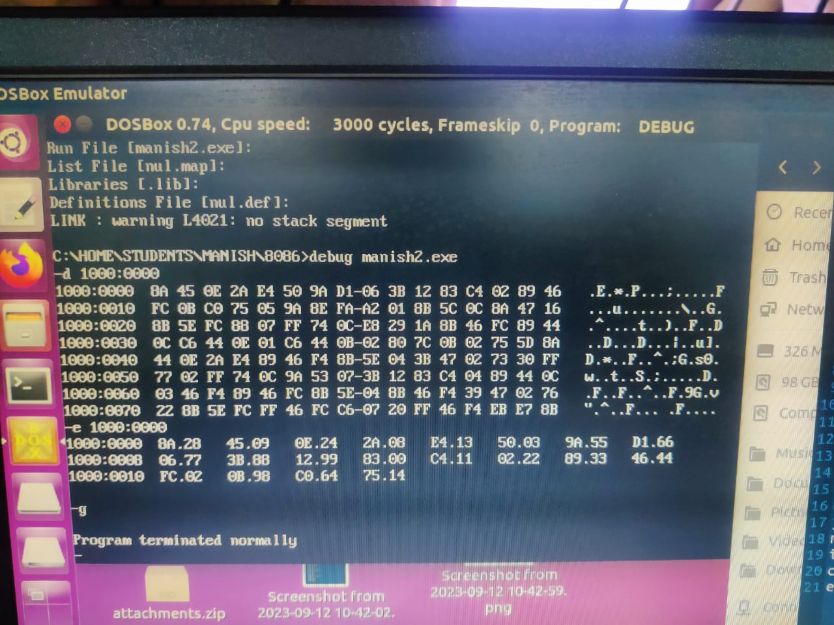

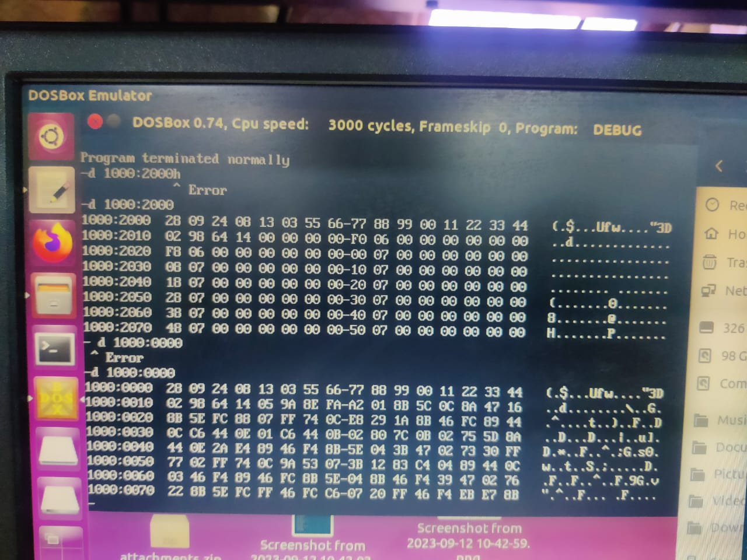

**TOPIC** :- COPYING 10 16-BIT NUMBERS FROM ONE SEGMENT TO ANOTHER SEGMENT.

**CODE** :-

data segment

data ends

code segment

assume cs:code, ds:data

start:

mov ax,1000h

mov ds,ax

mov si,0000h

mov di,0000h

mov cx,0Ah

mov ax,2000h

mov es,ax

xyz:

mov ax,[si]

mov es:[di],ax

add si,02

add di,02

dec cx

jnz xyz

mov ah,4ch

int 21h

code ends

end start

**OUTPUT** :-

